# Proposed Model:

MobileNet is a family of lightweight deep convolutional neural network architectures designed for mobile and embedded vision applications with limited computational resources [1].

The proposed model for this project will be MobileNet v2 on the dataset downloaded from Kaggle. The dataset consists of 25,077 images. The dataset will be divided into two parts, training (85%) and test (15%) data; 22,564 images set for training and 2,513 set for testing.

The model will be trained to learn different types of wastes provided in the dataset. The reason for using MobileNet is due to its high accuracy, which was evident in the literature review and the reason that it utilizes less resources which makes it best suited for a mobile application.

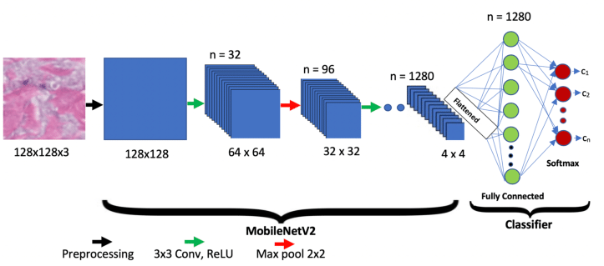

Figure 1 MobileNet Architecture [2]

We are proposing a mobile application built on flutter. The mobile application will let users scan waste, it would identify the type of waste whether the waste is organic, recyclable, or paper, and it would guide the user by letting them know which bin to throw the waste in. The application will use the concept of gamification, which would be there to trigger the dopamine effect. The users will have the option to add friends, create a group, and check their points in the application. The points are gained by recycling garbage. The more the user recycles garbage, the more points he/she will have. The user will scan waste which he/she is not sure of, and will use the application to throw the waste into the correct bin, the application will detect whether the waste is recyclable or not, and will inform the user to throw the waste into its respective bin, this whole activity will give the user a point, encouraging them to use the app more often and compete with their friends, making the process of recycling fun and rewarding. For the identification of waste, a model (MobileNet v2) trained on the dataset will be used.

# Workflow Diagram of the mobile Application:

The workflow diagram shows two scenarios, one in which the user scans for waste and the other in which the user adds friends. The user will use scan waste option to scan for waste which would store the image into database and request model to identify the type of waste, it will inform the user to throw the detected type of waste into a certain bin and add points to the user’s profile.

Th other use case is, the user will search for a friend using name or phone number and add them to their friends list.

## Innovation:

All the research papers we reviewed, did only classification and did not detect multiple objects in an image. We are proposing an application that will detect multiple waste objects. The application will grow awareness and contribute towards proper segregation and recycling of waste by helping users identify waste and by providing awareness.

# References:

[1] A. G. Howard et al., "MobileNets: Efficient Convolutional Neural Networks for Mobile Vision Applications," arXiv:1704.04861, 2017.

[2] Akay, M., Du, Y., Sershen, C. L., Wu, M., Chen, T. Y., Assassi, S., Mohan, C., & Akay, Y. M. (2021). Deep Learning Classification of Systemic Sclerosis Skin Using the MobileNetV2 Model. *IEEE Open Journal of Engineering in Medicine and Biology*, *2*, 104–110. https://doi.org/10.1109/ojemb.2021.3066097